CST2355 – Database Systems Lab Assignment 3  
Debug Issues

# Importing Excel Worksheet troubles:

**Symptom:** SQL Server Management Studio Version gives an error message that it cannot read the .xlsx (Excel 2016) file format. .

**Solution: *use Excel to store the file in .xls (the earlier version) format.***

# Importing Access Database troubles:

**Symptom:** SQL Server Management Studio Version 18.9.2 cannot import the Access 2016 database. When you try to change the file type to the .accdb (newest) type, it gives an error message about a missing component.

**Solution: *install a Microsoft solution using the following steps.***

Use the links below to download a new Access 2016 Database Engine which will provide an updated data import tool.

1. This is the link to download the driver for 64bits.

[Download Microsoft Access Database Engine 2016 Redistributable from Official Microsoft Download Center](https://can01.safelinks.protection.outlook.com/?url=https%3A%2F%2Fwww.microsoft.com%2Fen-us%2Fdownload%2Fdetails.aspx%3Fid%3D54920&data=04%7C01%7Ckingd%40algonquincollege.com%7Cdb6c78c4763d4dfcfe3c08d9837a2c06%7Cec1bd9240a6a4aa9aa89c980316c0449%7C1%7C0%7C637685383006251109%7CUnknown%7CTWFpbGZsb3d8eyJWIjoiMC4wLjAwMDAiLCJQIjoiV2luMzIiLCJBTiI6Ik1haWwiLCJXVCI6Mn0%3D%7C1000&sdata=K4bY7OTmnlvAMrr4DqcySfoMwjm3YIX6afvkXjlKeiE%3D&reserved=0)

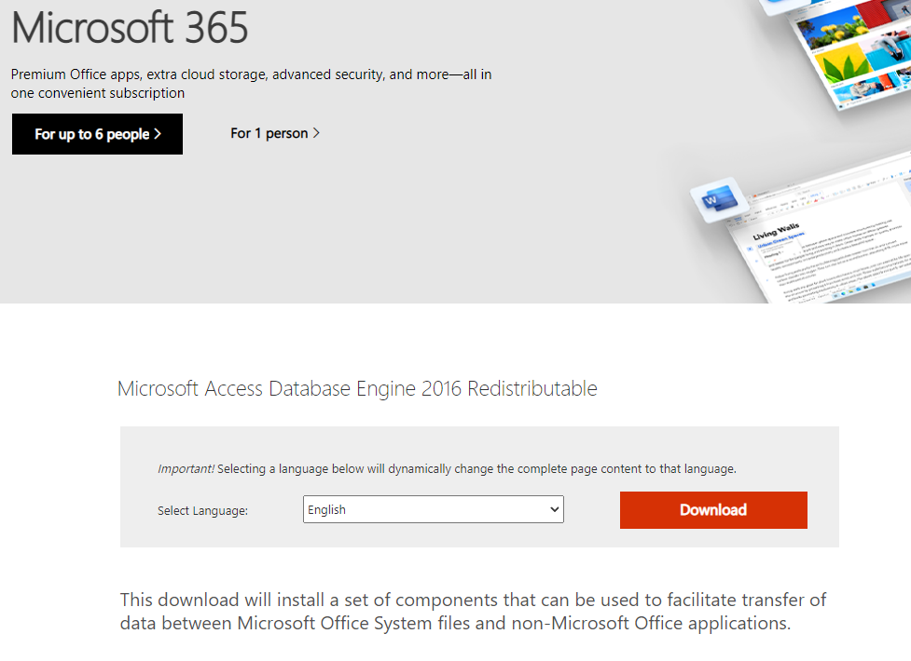

1. Click the "Download" button. Then you will see:

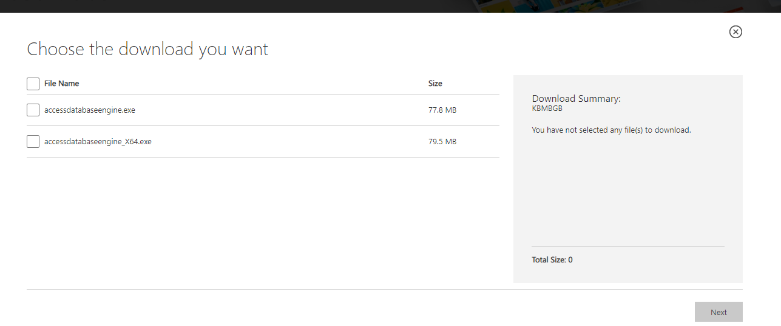

1. Then check the "accessdatabaseengine_X64.exe" option, press "Next" to download.
2. After installation of the driver, you can use the Windows Search facility to find the updated SQL Server data import and export tool. In the ‘Type here to search’ area type "SQL server 2019.... " to find the import and export tool.

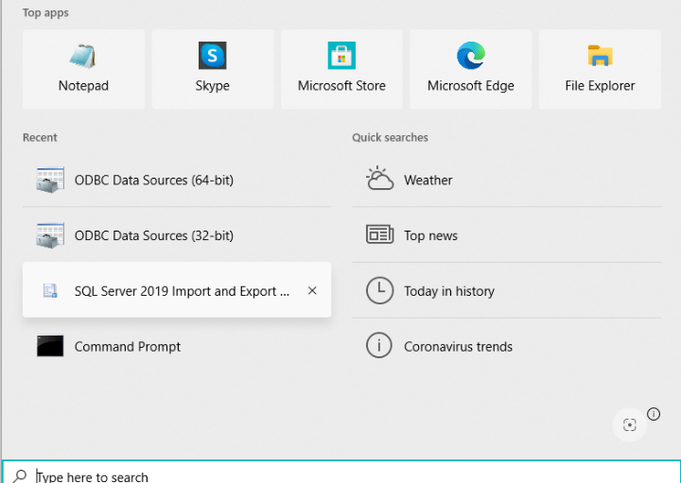

1. Open the tool.
2. You will now have two source options for Access when you try to import data into your database. Select the new one – as shown below.

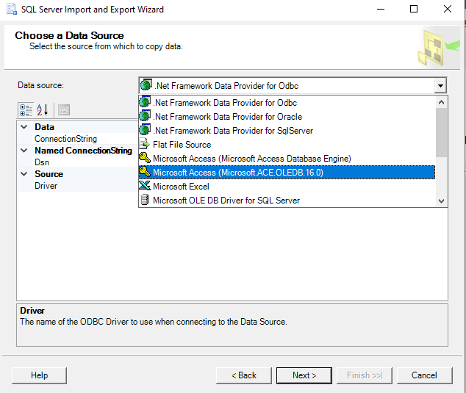

1. The new Access engine should be able to open the .accdb file and import your data tables.